Question?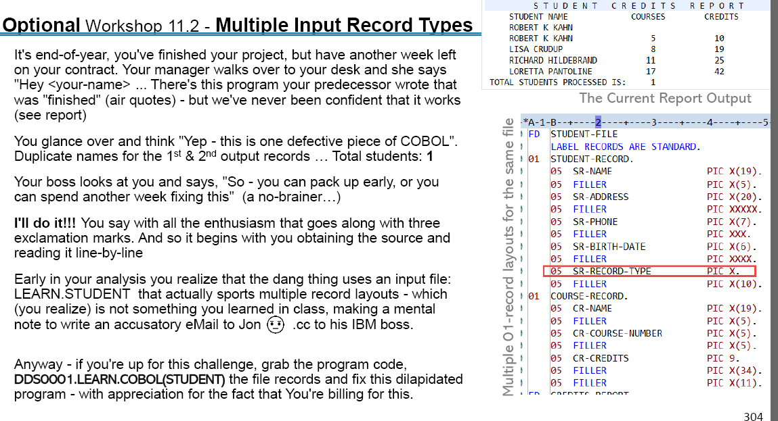

Answer :

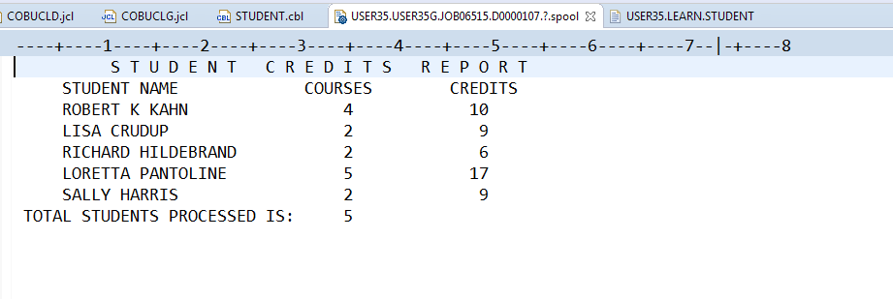

000100 IDENTIFICATION DIVISION. 00000100

000200 PROGRAM-ID. STUDENT. 00000200

000200\* 00000300

000300\* \*\*\*\*\*\*\*\*\*\*\*\*\*\*\*\*\*\*\*\*\*\*\*\*\*\*\*\*\*\*\*\*\*\*\*\*\*\*\*\*\*\*\*\*\*\*\*\*\*\*\* 00000400

000400\* \*\*\* student.cbl 00000500

000500\* \*\*\* 00000600

001000\* \*\*\* The program produces a report that shows 00000700

001100\* \*\*\* the number of courses and credits that 00000800

001200\* \*\*\* a student has taken. The input file has 00000900

001300\* \*\*\* two types of records, a student record showing 00001000

001400\* \*\*\* information about a student, followed by 00001100

001500\* \*\*\* a number of course records for that student. 00001200

001600\* \*\*\* Each course record shows the information 00001300

001700\* \*\*\* for a course taken by the student. 00001400

003000\* \*\*\* 00001500

003100\* \*\*\*\*\*\*\*\*\*\*\*\*\*\*\*\*\*\*\*\*\*\*\*\*\*\*\*\*\*\*\*\*\*\*\*\*\*\*\*\*\*\*\*\*\*\*\*\*\*\*\* 00001600

\* \*\*\*\*\*\*\*\*\*\*\*\*\*\*\*\*\*\*\*\*\*\*\*\*\*\*\*\*\*\*\*\*\*\*\*\*\*\*\*\*\*\*\*\*\*\*\*\*\*\* 00001700

003300 INSTALLATION. IBM. 00001800

003400 DATE-WRITTEN. 01-01-2009. 00001900

003500 DATE-COMPILED. 01-01-2009. 00002000

003600 SECURITY. NONE. 00002100

003700 ENVIRONMENT DIVISION. 00002200

003800 CONFIGURATION SECTION. 00002300

003900 SOURCE-COMPUTER. IBM. 00002400

004000 OBJECT-COMPUTER. IBM. 00002500

004100 INPUT-OUTPUT SECTION. 00002600

004200 FILE-CONTROL. 00002700

004300 SELECT STUDENT-FILE ASSIGN TO UT-S-STDNTFL 00002800

004300 ORGANIZATION IS SEQUENTIAL. 00002900

004400 SELECT CREDITS-REPORT ASSIGN TO PROPOSAL 00003000

004300 ORGANIZATION IS SEQUENTIAL. 00003100

004500 DATA DIVISION. 00003200

004600 FILE SECTION. 00003300

004700 FD STUDENT-FILE 00003400

RECORDING MODE IS F 00003500

LABEL RECORDS ARE STANDARD 00003600

RECORD CONTAINS 80 CHARACTERS 00003700

BLOCK CONTAINS 0 RECORDS 00003800

DATA RECORD IS STUDENT-IN-REC. 00003900

\* RECORD IS VARYING IN SIZE 00004000

\* FROM 43 TO 80 CHARACTERS DEPENDING ON REC-LEN. 00004100

01 STUDENT-IN-REC. 00004200

05 REC-BODY PIC X(69). 00004300

05 SR-RECORD-TYPE PIC X. 00004400

05 FILLER PIC X(9). 00004500

00004600

006700 FD CREDITS-REPORT 00004700

006800 RECORDING MODE IS F 00004800

LABEL RECORDS ARE STANDARD. 00004900

006900 01 REPORT-LINE-OUT PIC X(60). 00005000

007000 WORKING-STORAGE SECTION. 00005100

01 STUDENT-RCD-HDR. 00005200

05 SR-NAME PIC X(19). 00005300

05 FILLER PIC X(5). 00005400

05 SR-ADDRESS PIC X(20). 00005500

05 FILLER PIC XXXXX. 00005600

05 SR-PHONE PIC X(7). 00005700

05 FILLER PIC XXX. 00005800

05 SR-BIRTH-DATE PIC X(6). 00005900

05 FILLER PIC XXXX. 00006000

05 STUDENT-REC-TYPE PIC X. 00006100

05 FILLER PIC X(10). 00006200

01 COURSE-RCD-DTL. 00006300

05 CR-NAME PIC X(19). 00006400

05 FILLER PIC X(5). 00006500

05 CR-COURSE-NUMBER PIC X(5). 00006600

05 FILLER PIC X(5). 00006700

05 CR-CREDITS PIC 9. 00006800

05 FILLER PIC X(33). 00006900

05 COURSE-REC-TYPE1 PIC X. 00007000

05 COURSE-REC-TYPE2 PIC X. 00007100

05 COURSE-REC-TYPE3 PIC X. 00007200

007100 01 SWITCHES-IN-PROGRAM. 00007300

05 SW-END-OF-DATA PIC X VALUE 'N'. 00007400

88 END-OF-DATA VALUE 'Y'. 00007500

01 ACCUMS-AND-COUNTERS. 00007600

05 ACCUM-CREDITS PIC 999 VALUE 0. 00007700

05 CTR-COURSES PIC 999 VALUE 0. 00007800

05 CTR-STUDENTS PIC 9(5) VALUE 0. 00007900

05 CTR-LINES PIC 99 VALUE 0. 00008000

01 SAVE-AREAS. 00008100

05 SAVE-NAME PIC X(19). 00008200

01 GRAND-TOTAL-LINE. 00008300

05 FILLER PIC X(30) 00008400

VALUE 00008500

' TOTAL STUDENTS PROCESSED IS: '. 00008600

05 GTL-STUDENT-COUNT PIC ZZZZZ. 00008700

01 DETAIL-LINE. 00008800

05 FILLER PIC X(5) VALUE SPACE. 00008900

05 DL-NAME PIC X(19). 00009000

05 FILLER PIC X(8) VALUE SPACE. 00009100

05 DL-COURSES PIC ZZZ. 00009200

009000 05 FILLER PIC X(10) VALUE SPACE. 00009300

009100 05 DL-CREDITS PIC ZZZZ. 00009400

009200 01 HEADING-1. 00009500

009300 05 FILLER PIC X(10) VALUE SPACE. 00009600

009400 05 FILLER PIC X(80) VALUE 00009700

009500 'S T U D E N T C R E D I T S R E P O R T'. 00009800

009600 01 HEADING-2. 00009900

009700 05 FILLER PIC X(5) VALUE SPACE. 00010000

009800 05 FILLER PIC X(25) VALUE 'STUDENT NAME'. 00010100

009900 05 FILLER PIC X(15) VALUE 'COURSES'. 00010200

010000 05 FILLER PIC X(7) VALUE 'CREDITS'. 00010300

77 REC-LEN PIC 99. 00010400

\* 00010500

010100 PROCEDURE DIVISION. 00010600

010200 000-TOP-LEVEL. 00010700

010300 PERFORM 100-INITIALIZATION. 00010800

010400 PERFORM 200-PROCESS-RECORDS UNTIL END-OF-DATA. 00010900

010500 PERFORM 800-WRAP-UP. 00011000

010600 GOBACK. 00011100

010700 100-INITIALIZATION. 00011200

010800 OPEN INPUT STUDENT-FILE. 00011300

010900 OPEN OUTPUT CREDITS-REPORT. 00011400

011000 PERFORM 400-PAGE-CHANGE-RTN. 00011500

011100 PERFORM 700-READ-A-RECORD. 00011600

011400 200-PROCESS-RECORDS. 00011900

011500 IF SR-RECORD-TYPE = '1' THEN

MOVE STUDENT-IN-REC TO STUDENT-RCD-HDR 00012100

DISPLAY STUDENT-RCD-HDR

IF CTR-STUDENTS = 0 THEN

MOVE SR-NAME TO SAVE-NAME

END-IF

IF SR-NAME NOT = SAVE-NAME THEN

\* CHECK IF NEW STUDENT (new HEADER RECORD FOUND) 00012400

PERFORM 900-WRAP-UP-RECORD

END-IF 00013000

011700 PERFORM 300-PROCESS-1ST-REC-HDR 00013100

011800 MOVE SR-NAME TO SAVE-NAME 00013200

012000 ELSE 00013300

MOVE STUDENT-IN-REC TO COURSE-RCD-DTL 00013400

011700 PERFORM 600-PROCESS-2ND-REC-DTL 00013500

END-IF 00013600

012200 PERFORM 700-READ-A-RECORD. 00013700

IF CTR-LINES IS GREATER THAN 30 00013800

012600 PERFORM 400-PAGE-CHANGE-RTN 00013900

END-IF. 00014000

012300 300-PROCESS-1ST-REC-HDR. 00014100

ADD 1 TO CTR-STUDENTS. 00014200

013200 400-PAGE-CHANGE-RTN. 00014300

013300 WRITE REPORT-LINE-OUT FROM HEADING-1 00014400

013400 AFTER ADVANCING PAGE. 00014500

013500 WRITE REPORT-LINE-OUT FROM HEADING-2 00014600

013600 AFTER ADVANCING 2. 00014700

013700 MOVE ZERO TO CTR-LINES. 00014800

013800 500-BUILD-DETAIL-LINE. 00014900

013900 MOVE SAVE-NAME TO DL-NAME. 00015000

014000 MOVE CTR-COURSES TO DL-COURSES. 00015100

014100 MOVE ACCUM-CREDITS TO DL-CREDITS. 00015200

014200 600-PROCESS-2ND-REC-DTL. 00015300

014300 ADD CR-CREDITS TO ACCUM-CREDITS. 00015400

014400 ADD 1 TO CTR-COURSES. 00015500

014500 700-READ-A-RECORD. 00015600

014600 READ STUDENT-FILE 00015700

014700 AT END 00015800

MOVE 'Y' TO SW-END-OF-DATA 00015900

END-READ. 00016000

014800 800-WRAP-UP.

PERFORM 900-WRAP-UP-RECORD.

014900 MOVE CTR-STUDENTS TO GTL-STUDENT-COUNT. 00016200

015000 WRITE REPORT-LINE-OUT FROM GRAND-TOTAL-LINE 00016300

015100 AFTER ADVANCING 2. 00016400

015200 CLOSE CREDITS-REPORT STUDENT-FILE.

900-WRAP-UP-RECORD.

PERFORM 500-BUILD-DETAIL-LINE.

012800 WRITE REPORT-LINE-OUT FROM DETAIL-LINE

012900 AFTER ADVANCING 1 .

MOVE ZEROS TO CTR-COURSES .

MOVE ZEROS TO ACCUM-CREDITS.